ALL TEST 6.31 Analysis Results

Performance Summary

Bottom Line
X This induction motor is operating normally, no action is required.
This induction motor exhibits suspicious operation, trending of the induction motor is warranted.
This induction motor exhibits abnormal indications, action is warranted, NOW.

Power Factor Commentary
Power factor exceeds 0.85.
X Power factor is below 0.85, see detailed report.

Current Commentary
X Current variation is within normal limits.
Current variation is beyond normal limits, see detailed report.

Voltage Commentary
X Voltage variation is within normal limits.
Voltage variation is beyond normal limits, see detailed report.
RMS voltage differs from nameplate by more than 5%.

Load Commentary
X Load on the induction motor is consistent with nameplate values.
Load on the induction motor exceeds nameplate values, see detailed report.
Load on the induction motor is less than 25%.

Phase Connection Commentary
X Connections are normal.
Voltage ground reference is NOT neutral.
Loose connection.

Rotor Commentary
X Rotor bar health is normal.
Rotor bar health is questionable, see detailed report.
Load is insufficient to determine rotor bar health, at this time.

Stator Commentary
X Stator health is normal.
Stator mechanical health is questionable. .
Turn to turn short.

Rotor/Stator Air-gap Characteristics
X Dynamic or static eccentricity indications do not exist.
Indications of static eccentricity exist .
Indications of dynamic eccentricity exist.

Harmonic Distortion Commentary
X There is no evidence of harmonic distortion.
There is evidence of harmonic distortion, see detailed report.

Misalignment Indications
X There are no indications of mechanical problems like misalignment or unbalance.
There are indications of mechanical problems like misalignment / unbalance. Perform vibr. survey to identify and correct the cause.

INPUT SUMMARY

NAMEPLATE INFORMATION
 |  | Units
Manufacturer | WISTIN
Serial Number | J60002
Model Number | EN60034 IEC 600
Tested Equipment | Induction
Power | 73.73 | HP
RPM | 1480.0 | Rpm
Poles | 4
Phases: | 3
Voltage | 400.0 | Volt
Full Load Current | 98.10 | Amp
No Load Current | 3.00 | Amp
Number of rotor bars | 42
Number of stator slots | -1
Torque | 261.5 | Ft.Lb
CT Ratio | 1.000
Service Factor | 115
Motor efficiency | -1.000
Power factor | -1.000

Description:
Belum ada data rotor bar dan stator slot

LEGENDS:
Impedance | = Complex Impedance = vi/ci
CF | = Crest Factor = (waveform peak)/(waveform rms)
VDF | = Transformer Harmonic De-rating Factor = sqrt(2)/CF, %

Slip % | = SRSS sum of slip and harmonic "levels" divided by RMS level of RMS DEMOD spectra between 0 and 65 Hz.
Upper sb | = dB level of upper slip sideband of power line peak
Lower sb | = dB level of lower slip sideband of power line peak
Se, fund | = Location of pole pass frequency fundamental, Hz
Se, harm | = Number of pole pass frequency harmonics
Rotor bar health | = Estimate of the percent of broken or cracked rotor bars
RB Hlt Index | = Rotor bar health index

THDF | = Voltage De-rating Factor = 100 - (voltage unbalance, %)^2, %
Level | = Sum of spectral amplitudes of pole pass frequency fundamentals and harmonics
Thd | = Total harmonic distortion
+Ve | = Positive sequence harmonic
-Ve | = Negative sequence harmonic
Zero | = Zero sequence harmonic

Detailed Calculations

Running Speed = 21.896 Hz [1314 RPM]

Pole pass frequency = 12.512 Hz [751 RPM]

Load = 71.4 %
Time
 | RMS | Peak | CF
Current 1 | 74.060 | 105.470 | 1.424
Current 2 | 73.910 | 105.260 | 1.424
Current 3 | 74.370 | 105.910 | 1.424
Average | 74.113 | 105.550 | 1.424
% dev | 0.3 | 0.3 | 0.0

THDF = 99.3

Time
 | RMS | Peak | CF
Voltage 1 | 391.900 | 551.980 | 1.408
Voltage 2 | 391.900 | 551.980 | 1.408
Voltage 3 | 392.300 | 552.550 | 1.408
Average | 392.030 | 552.170 | 1.408
% dev | 0.1 | 0.1 | 0.0

VDF = 100.0
* Note-
Phase 2 and 3 CF and peak entries are assumed to be the same as phase-1.

 |  |  | App. Power | Real Power | Reac. Power
 | Power factor | Impedance | kVA | kW | kVARS
Phase 1 | 0.839 | 5.292 | 16.775 | 14.076 | 9.124
Phase 2 | 0.846 | 5.302 | 16.696 | 14.123 | 8.905
Phase 3 | 0.843 | 5.275 | 16.845 | 14.195 | 9.069
Avg/Total | 0.843 | 5.290 | 50.316 | 42.394 | 27.099
% dev | 0.4 | 0.3

Demand Pwr = 56.83 HP

Load:71.4 %

Motor Eff.:92.3 %

Loss due to THD:

Output Pow.:38.62 KW

Output Trq.:206.90 Ft.Lb

Summary of Rotor Bar Health |  |  |  |  | Power line dB diff. |  | RB Hlt Index
 | Se, fund |  | Se, harm | Level % | Upper SB | Lower SB | RB Hlt Index
Measured | 12.512 |  | 3 | 0.1 | -62.581 | -63.065 | 0.097
Severity level |  | Rotor Condition Assessment |  |  | Recommended Corrective Action
2 |  | Good |  |  | None

Harmonic Distortion Results:
Voltage input, from 50.018 Hz harmonics
 | THD Odd % | THD Even % | +ve% | -ve % | Zero % | THD All %
Current 1 | 1.564 | 0.145 | 0.214 | 1.519 | 0.340 | 1.571
Current 2 | *** | *** | *** | *** | *** | ***
Current 3 | *** | *** | *** | *** | *** | ***
Voltage 1 | 0.787 | 0.074 | 0.130 | 0.761 | 0.173 | 0.791
Voltage 2 | *** | *** | *** | *** | *** | ***
Voltage 3 | *** | *** | *** | *** | *** | ***

Harmonic distortion table – Peak values, voltage is phase to ground
Hz | Cur1 | Vlt1 | Cur2 | Vlt2 | Cur3 | Vlt3
50 | 104.3 | 322 | *** | *** | *** | ***
100 | 0.2 | 0 | *** | *** | *** | ***
150 | 0.4 | 1 | *** | *** | *** | ***
200 | 0.0 | 0 | *** | *** | *** | ***
250 | 1.6 | 2 | *** | *** | *** | ***
300 | 0.0 | 0 | *** | *** | *** | ***
350 | 0.2 | 0 | *** | *** | *** | ***
400 | 0.0 | 0 | *** | *** | *** | ***
450 | 0.0 | 0 | *** | *** | *** | ***
500 | 0.0 | 0 | *** | *** | *** | ***
550 | 0.1 | 0 | *** | *** | *** | ***
600 | 0.0 | 0 | *** | *** | *** | ***

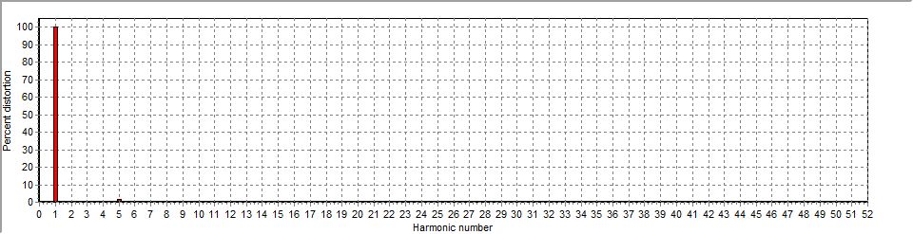
Figure 1: Current harmonic distortion plot

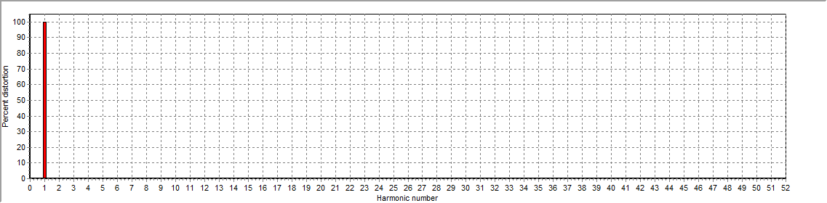
Figure 2: Voltage harmonic distortion plot

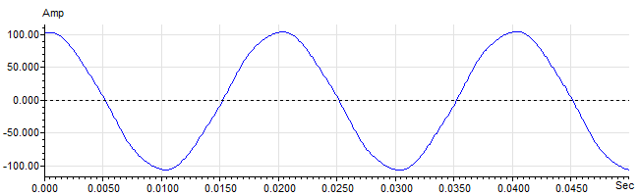
Figure 3: Raw Current

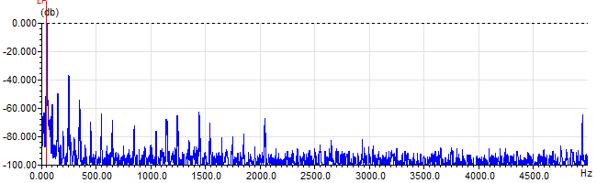
Figure 4: Raw Current Frequency spectrum

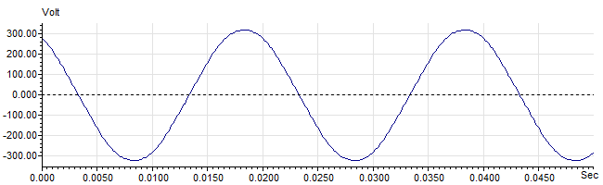
Figure 5: Raw Voltage

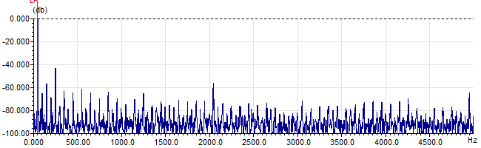
Figure 6: Raw Voltage Frequency spectrum

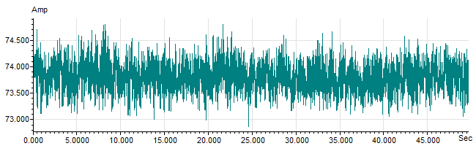
Figure 7: Demodulated current trace

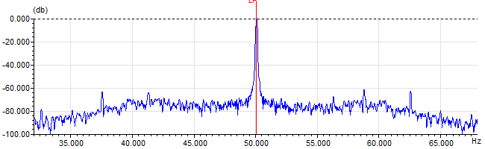
Figure 8: Raw current spectrum

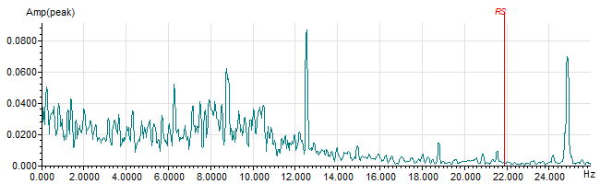
Figure 9: Demodulated current spectrum

